Methods Test 1 Notes – Year 11 2023

By Ajay Bisnath

**Fundamentals of Probability:**

P(A $∩$ B) =

* 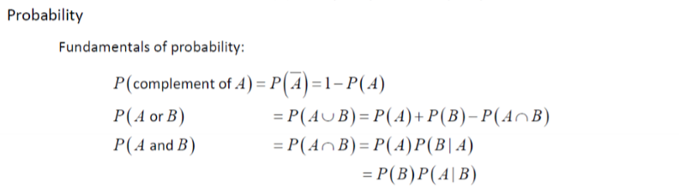P(A) * P(B|A)
* P(B) * P(A|B)

If Events are Independent:

* P(A $∩$ B) = P(A) * P(B)
* P(A|B) = P(A)

Bayes Formula:

* P(A|B) = $\frac{P(B|A) * P(A)}{P(B)}$

If A $⊆$ B:

* P(A $∪$ B) = B
* P(A $∩$ B) = A

Tips:

* Use a table for two-way Venn diagrams!! Makes things significantly easier!

|  |  |  |  |
| --- | --- | --- | --- |
|  | B | B’ | Total |
| A | *x* | *-* | *0.6* |
| A’ | *-* | *0.1* | *0.4* |
|  | *0.7* | *0.3* |  |

* E.g.:

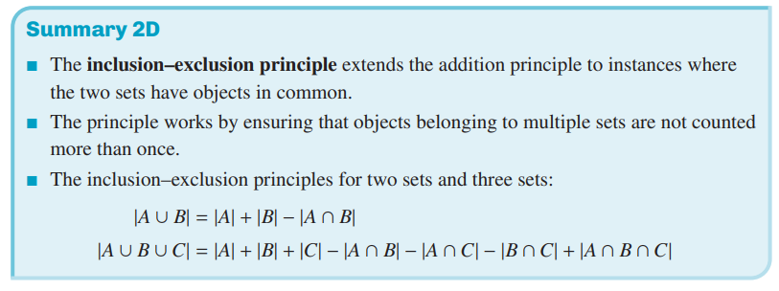**Lines and Linear Relationships:**

Slope:



$\frac{rise}{run}= \frac{∆y}{∆x}$

Midpoint, point in between two coordinates:

* (x1 + x2)/2 = x coordinate
* (y1 + y2)/2 = y coordinate

Perpendicular lines have the negative reciprocal gradient:

* E.g: $y = 2x + 3$ and $y = -\frac{1}{2}x+7$ are perpendicular lines
* If two lines gradient are the same (m), the lines are parallel
  + m is the coefficient of x

Remember that you can factorise equations like:

$s^{2}+ sp – sq – pq = (s + p)(s – q)$

$s^{2}-r^{2}=(s-r)(s+r)$

$ax+bx=x(a+b)$

If you can’t isolate a term:

* Can you swap negative terms to positive terms
* Check if you can factorise or expand anything
* Check if you can simplify anything
* Check if you can take out like terms:

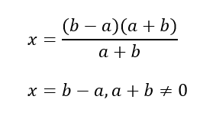[E.g.: $sp – sq – sr = s(p – q – r)$]

**Important! If you cancel out the bottom of a fraction, you must assume those terms $≠$ 0!!**

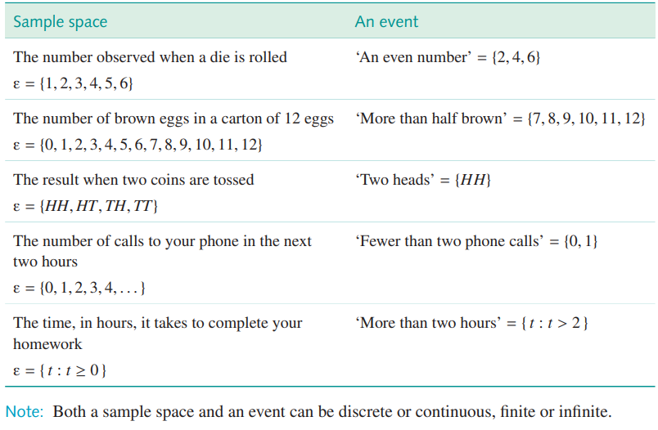**Sample Spaces:**

* Represent an empty set with $∅$
  + {0} is a set with zero in it
* Events are subsets of a sample space

